Church Administration Policy

The below admin structure desires to create centralized leadership, accountability, and effective management, promoting spiritual growth and alignment with the church’s mission. For more detailed requirements of the Lead Pastor, Elders, and Staff please see the 12SBC bylaws. This document is intended to be fluid and will be evaluated as the elders feel led.

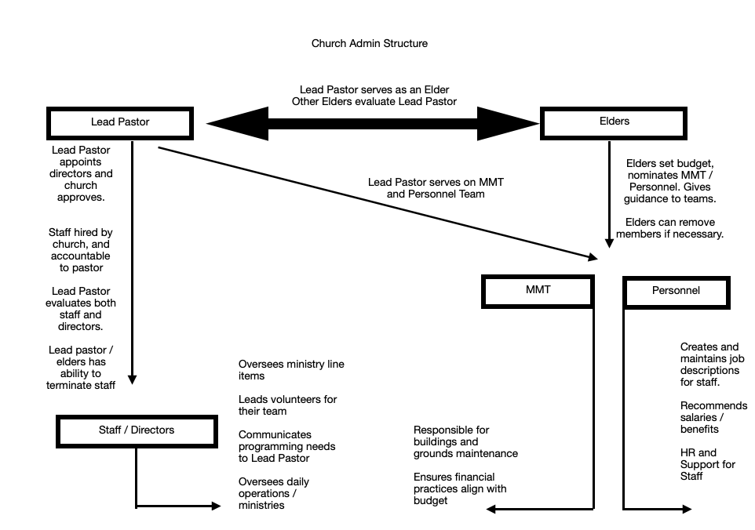

- Lead Pastor

The Lead Pastor provides overall spiritual leadership and vision for the church, serving as the chief shepherd (under Christ) and administrator. The Lead Pastor, in addition to his duties laid out in the constitution in by-laws, is responsible for appointing Directors, who will be presented to the church on a yearly basis for approval. The Lead Pastor will evaluate ministerial staff and recommend programming budgets to the elders.

- The Lead Pastor will assemble staff and Directors for coordination meetings to ensure all ministry activities align with the church's mission and strategy. The Lead Pastor will also conduct evaluations of the staff.
- The Lead Pastor will evaluate Directors yearly to ensure their ministry aligns with the church's mission and objectives. Additionally, the Lead Pastor will provide leadership to the Ministry Management Team and ensure that all ministry activities align with the church’s vision and strategy.
- The Lead Pastor will be evaluated by the other Elders. This would include his work performance, his conduct and spiritual growth, and ability to lead the congregation. In addition to this his salary and benefits will be determined by the Elders.
- If the unfortunate situation arises that the Lead Pastor must be dismissed, the procedure as listed in the by laws will be followed.
- The Lead Pastor will serve in an ex-officio manner on both the personnel team and the MMT.

2. Elders

The Elders provide spiritual oversight and guidance for the church, ensuring all decisions align with its mission and values. In addition to their spiritual responsibilities as laid out in the constitution and bylaws, the Elders:

- Serve as the nominating team for the Ministry Management Team. Elders will prayerfully consider spiritually mature and dedicated church members who have displayed spiritual gifts and maturity that will aid in church management.
- Determine ministerial staff compensation for inclusion in the budget. Lead Pastor will abstain from the decision making for his compensation and package.
- Write, develop, and approve the annual budget, which is submitted to the congregation for final approval.
- Conduct evaluations for the Lead Pastor (performed by non-staff, lay Elders).
- Will set the Lead Pastors salary and benefits (including sabbaticals, time off, sick days, and vacation time)
- Provide direction and goals to the Ministry Management Team and Personnel Team, ensuring alignment with the church’s mission.
- Reserve the right to remove a member from the Ministry Management Team if necessary.
- Direct and Approve church renovations to ensure alignment with the church’s mission and needs. Operations of church renovations will be delegated to the Ministry Management Team
- Oversee the hiring of all staff, ensuring alignment with the church’s mission and vision. Elders may delegate hires to the MMT.

3.Ministry Management Team

The Ministry Management Team is responsible for executing the vision and direction handed to them by the Elders. This team manages church administration, finances, personnel (excluding the Lead Pastor), and facilities.

The Ministry Management Team consists of a number of members determined by the elders, plus the Lead Pastor in an ex-officio manner (team members will servie no more than a 3 year term). This team will consist of spiritually mature members who have displayed their gifts in the life of this church. The Lead Pastor will chair the team but abstain from voting (except in the case of a tie). Members are nominated by the Elders and approved by the church.

The Ministry Management Team will assist with:

- Budget Management:
Implement the budget created and approved by the Elders and congregation.
Can redistribute budget items as necessary without exceeding the total approved budget. Has the authority to temporarily freeze non-essential (essential spending being salaries, building and administration) spending during budget shortfalls or financial constraints. This action may be overridden by the Elders if deemed necessary.
- Building and Grounds:
Oversees the maintenance, operation, and improvement of church facilities. The MMT will function as the trustees of the church, being able to sign legal documents of the church.
- Operational Execution:
Is responsible for carrying out major decisions and directives set by the Elders, including approved renovations and logistical matters.
- Asset Management:
Approves the sale, donation, or disposal of church-owned items that are no longer relevant to ministry, excluding real property (e.g., land or buildings), which requires congregational approval.
- Accountability and Reporting:
Report to the congregation through quarterly updates and an annual report presented during the church’s family meetings.
- Team Dynamics:
May divide into subgroups or delegate certain tasks (e.g., financial help with the Budget, and Buildings & Grounds) as necessary to address specialized areas. Each subgroup may enlist additional volunteers, with approval from the full team, to assist in its responsibilities.

4. Personnel Team

The Personnel Team serves as the support of the staff. The Personnel Team will help with create and maintain job descriptions, recommend salaries and benefits, and serve as the HR arm of the church for the staff . This team should view their ministry as caring for and ministering to the staff of the church and the church as a whole. The Lead Pastor will serve on the Personnel Team and he will be evaluated by the elders of the church. Members of the Personnel Team are nominated by the Elders and approved by the church.

The Personnel Team will assist with

- Oversees personnel matters for staff to ensure alignment with the church’s mission and the vision of the Lead Pastor and Elders.
- May assist with the hiring process of ministry support staff when delegated by the elders.
- Will recommend budget suggestions to the elders in regard to creating new staff or adjusting staff compensation.
- Will recommend budget, package suggestions, and time off to the elders in regards to benefits for staff.
- Will create and maintain job descriptions for each staff member (excluding the Lead Pastor who’s job description is created and maintained by the elders).
- Will determine personal days, sick days, benefits, and vacation time for staff members.
- Will receive staff evaluations from the Lead Pastor and review them as a group.
- Will evaluate the budget and needs of staff to make sure that staff are being properly cared for and respected.
- Will be able to help with any disputes or problems that may occur within the staff of the church.
- The termination of a staff member will be determined by the Lead Pastor and Elders, but the personnel team will be willing to give feedback and consultation.

5. Directors and Ministry Leaders

Directors and Ministry Leaders are appointed by the Lead Pastor, affirmed by the Elders, and confirmed by an annual vote of the church body.

- Directors and Ministry Leaders report to the Lead Pastor and align their ministry work with the church’s mission and objectives. The Lead Pastor will evaluate Directors yearly to ensure alignment with church goals and effectiveness in their leadership.
- Directors will oversee their budgeted line items and coordinate volunteer ministry teams.
- In unfortunate cases, a Director can be removed by the Elders.

6. Staff Responsibilities

- Staff members are responsible for the day-to-day operations of their respective ministries.
- Staff members report to the Lead Pastor, who has the authority to terminate staff members as necessary. The Lead Pastor will consult with the Elders prior to terminating any staff member.
- Staff members will oversee their budgeted line items and coordinate volunteer ministry teams if applicable.
- In unfortunate cases, a staff member can be terminated by the Lead Pastor with consultation of the elders.
- Staff members will receive quarterly evaluations / coaching / goal setting with the Lead Pastor. The signed reports will then be given to the Personnel Team and kept on file.
- Staff members will interact and be in communication with the Lead Pastor and Personnel Team to ensure a safe and agreeable working environment.

7. Congregation’s role in administration

The congregation plays a vital role in affirming major decisions, including:

- Approving the Annual Budget: Final approval of the budget proposed by the Elders.
- Real Property Decisions: Approve the sale, donation, or purchase of real property (e.g., land, buildings).
- Leadership Affirmation: Affirmation of key leaders such as Directors and Ministry Management Team / Personnel Team members as presented.
- Maintain rights and privileges: The congregation still maintains all right and authority as listed in the constitution and by-laws.

8. Annual Meeting and Family Meeting Expectations

During the annual meeting, the following will take place:

- The Lead Pastor will present a list of appointed Directors, which will then be approved by the church body.
- All Directors are subject to annual reapproval to ensure alignment with the church’s mission and objectives.
- The Ministry Management Team will present the proposed budget for the upcoming year, which will be approved by the congregation.
- Elders, Lead Pastor, Staff, and Directors may give ministry reports at quarterly family meetings.

This structure will be reviewed by the elders as led. The elders may deem it necessary to adjust, alter, or change this structure. Any and all changes to this policy should be presented by the elders to the church for approval.

